## Team name and list of team members:

Team name: **Voltron**Team members:

* Mihail Aleksiev
* Nilolay Genov
* Stamo Petkov
* Svetlin Panov
* Todor Miroleskov

## Project purpose – what problem we solve:

Our project consists of two parts.

The first part is about a different types of facilities, their personal and the people who want to take a rest in some of the facilities. First of all we implement abstract class named “Facility” which is parent of “Hotel”, “Motel”, “Hostel” and “Chalet” classes. The classes “Sea Hotel” and “GolfAndSpa” are inherited from the “Hotel” class. For the “Room” class we have implemented a couple of properties that say the number of the room, if the room is cleaned or not, if it is free or not, the numbers of the beds in it, and if it is a single, double, triple room or an apartment. We have also put enumeration for the facilities. You can pick from one star to five star holiday house.

In the second part of the project we implement a couple of classes with few methods in them. The main class here is “Person” which is inherited by the classes “Client” and “Personal”. For example every facility has its “Personal” which is parent of the “Receptionist”, “Housekeeping” and “Manager” classes. Every person in our project, no matter personal or client, has its ID and Name. The receptionist can check how much money the client have to ensure that he/she can afford a room or not and to take money from the customers’ bill by the interface “IPay”. Also the receptionist greets the client by the interface “IComunicate” in four different languages which are defined in the enumeration “Languages”. The “Housekeeping” class is defined to clean the rooms and is called by the event “CleanRoom” when a room is freed. The “Manager” class has methods to hire and release personal. The trick here is that only the “Facility” class can hire a new manager.

## Class diagram of our types:

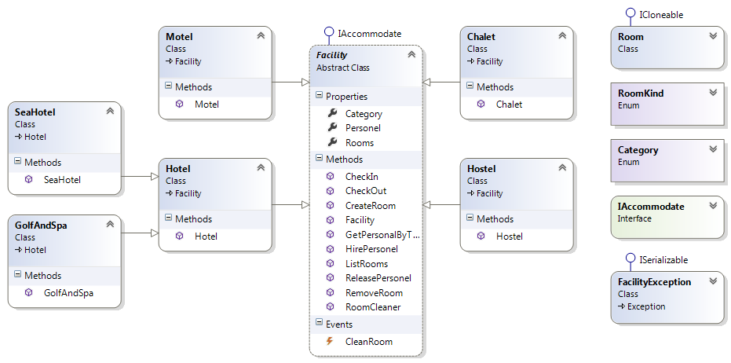

**Facility class diagram.**

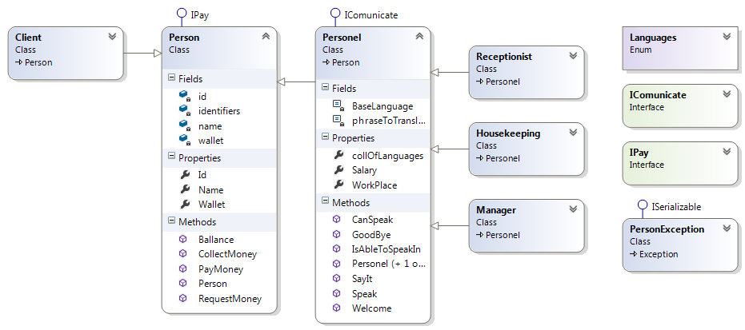

**Person class diagram.**

## The URL of your TFS repository:

<https://stamopetkov.visualstudio.com/>

## Other information: